**EXP NO 1**

CREATE A SIMPLE CLOUD SOFTWARE APPLICATION AND PROVIDE IT AS A SERVICE USING ANY CLOUD SERVICE PROVIDER TO DEMONSTRATE SOFTWARE AS A SERVICE (SAAS).

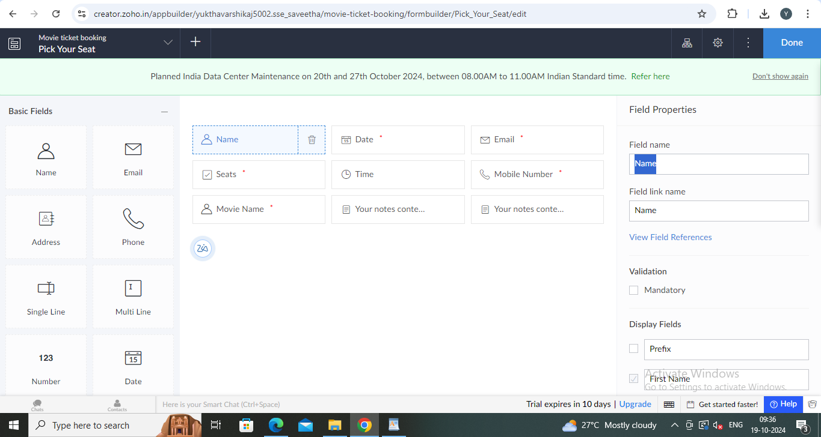

**EXP NO 2**

CREATE A SIMPLE CLOUD SOFTWARE APPLICATION FOR FLIGHT RESERVATION SYSTEM USING ANY CLOUD SERVICE PROVIDER TO DEMONSTRATE SAAS.

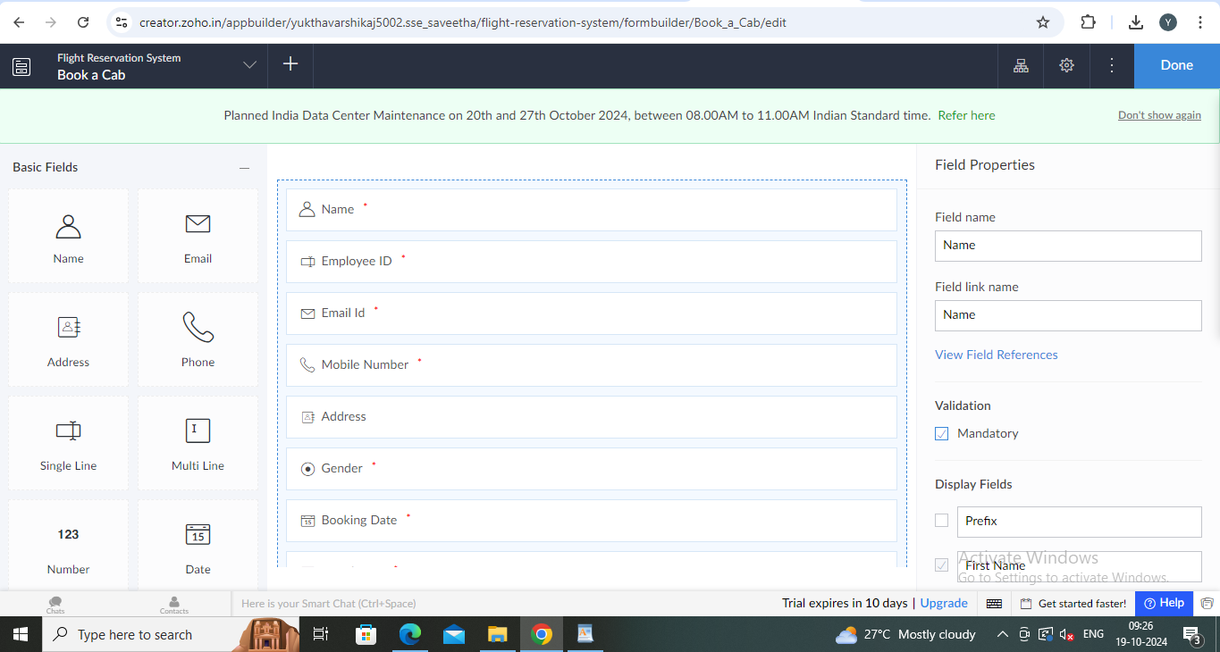

**EXP NO 3**

CREATE A SIMPLE CLOUD SOFTWARE APPLICATION FOR PROPERTY BUYING & RENTAL PROCESS (IN CHENNAI CITY) USING ANY CLOUD SERVICE PROVIDER TO DEMONSTRATE SAAS.

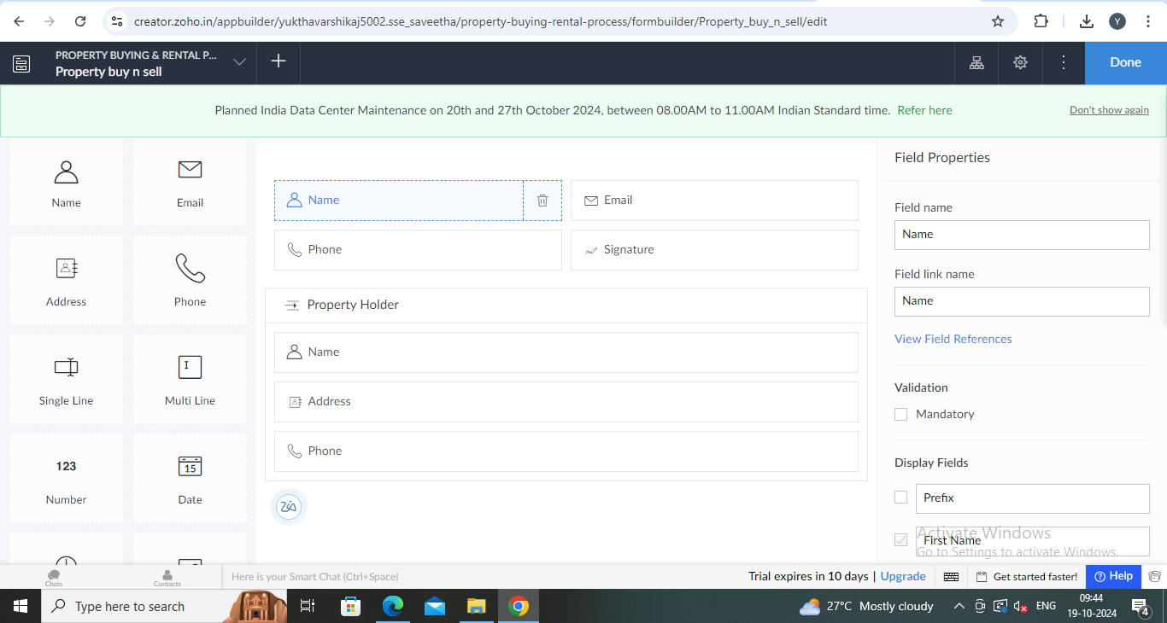

**EXP NO 4**

CREATE A SIMPLE CLOUD SOFTWARE APPLICATION FOR CAR BOOKING RESERVATION SYSTEM USING ANY CLOUD SERVICE PROVIDER TO DEMONSTRATE SAAS.

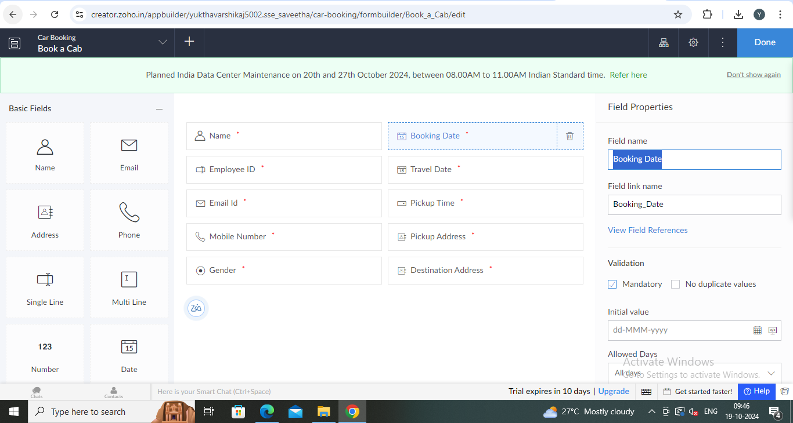

**EXP NO 5**

CREATE A SIMPLE CLOUD SOFTWARE APPLICATION FOR LIBRARY BOOK RESERVATION SYSTEM FOR SIMATS LIBRARY USING ANY CLOUD SERVICE PROVIDER TO DEMONSTRATE SAAS

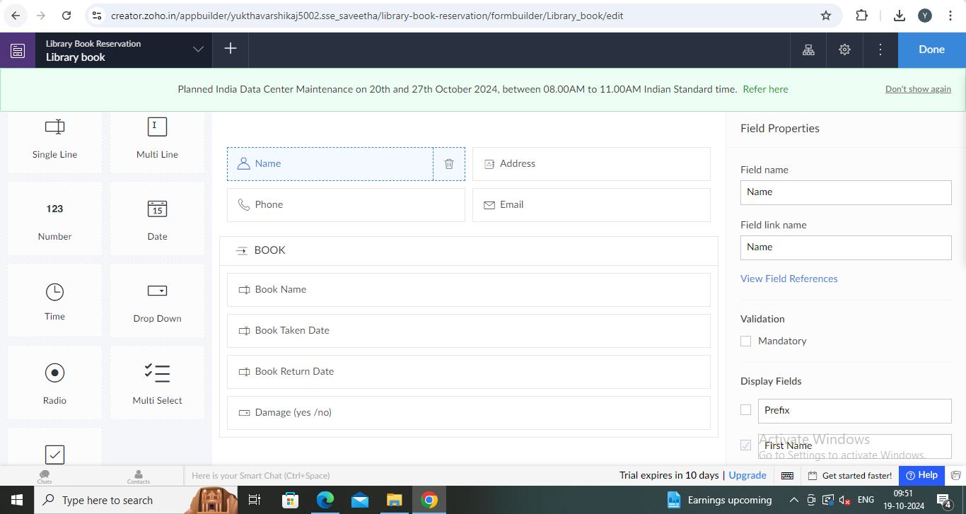

**EXP NO 6**

CREATE A SIMPLE CLOUD SOFTWARE APPLICATION FOR PRODUCT SELLING USING ANY CLOUD SERVICE PROVIDER TO DEMONSTRATE SAAS.

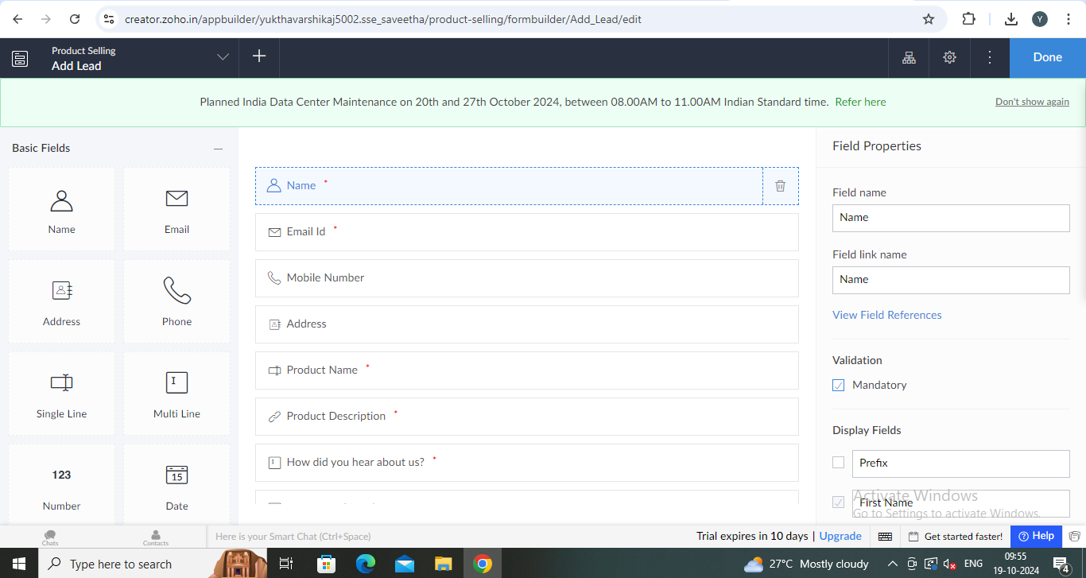

**EXP NO 7**

DEMONSTRATE VIRTUALIZATION BY INSTALLING TYPE-2 HYPERVISOR IN YOUR DEVICE, CREATE AND CONFIGURE VM IMAGE WITH A HOST OPERATING SYSTEM (EITHER WINDOWS/LINUX).

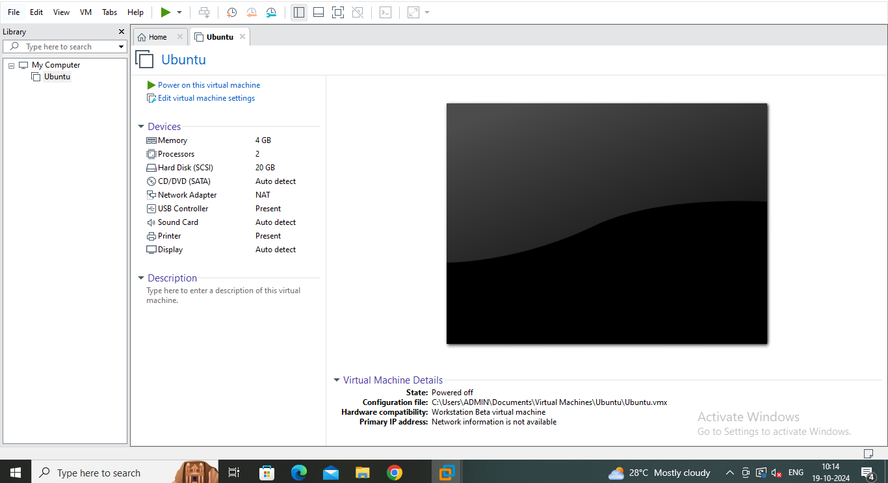

**EXPNO 8**

CREATE A VIRTUAL MACHINE WITH 1 CPU, 2GB RAM AND 15GB STORAGE DISK USING A TYPE 2 VIRTUALIZATION SOFTWARE.

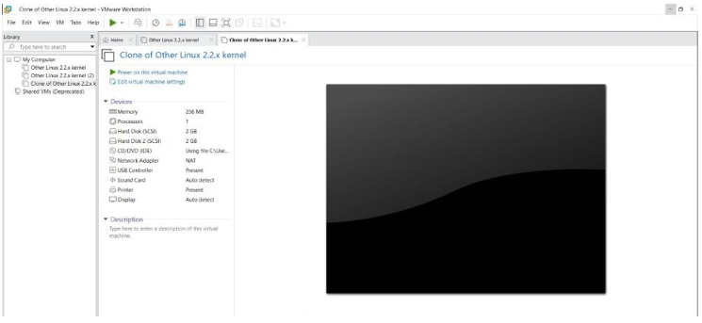

**EXP NO 9**

CREATE A VIRTUAL HARD DISK AND ALLOCATE THE STORAGE USING VM WARE WORKSTATION.

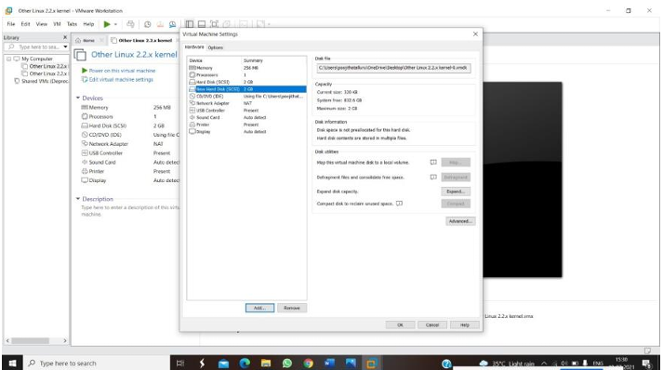

**EXP NO 10**

CREATE A SNAPSHOT OF A VM AND TEST IT BY LOADING THE PREVIOUS VERSION/CLONED VM

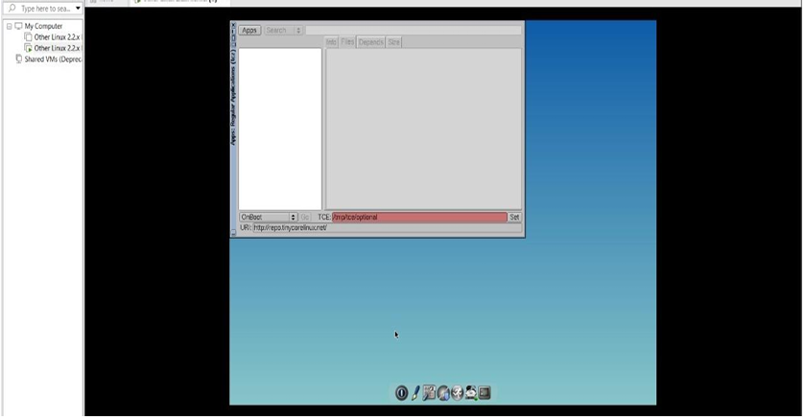

**EXP NO 11**

CREATE A CLONING OF A VM AND TEST IT BY LOADING THE PREVIOUS VERSION/CLONED VM.

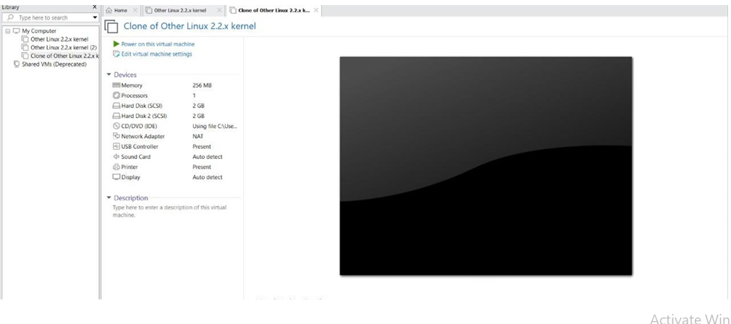

**EXP NO 12**

CHANGE HARDWARE COMPATIBILITY OF A VM (EITHER BY CLONE/CREATE NEW ONE) WHICH IS ALREADY CREATED AND CONFIGURED.

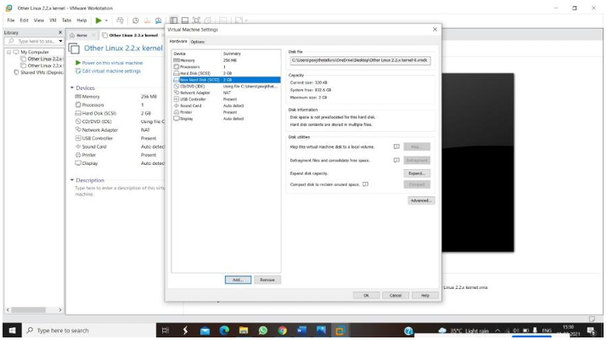

**EXP NO 13**

DEMONSTRATE INFRASTRUCTURE AS A SERVICE (IAAS) BY CREATING A VIRTUAL MACHINE USING A PUBLIC CLOUD SERVICE PROVIDER (AZURE), CONFIGURE WITH REQUIRED MEMORY AND CPU.

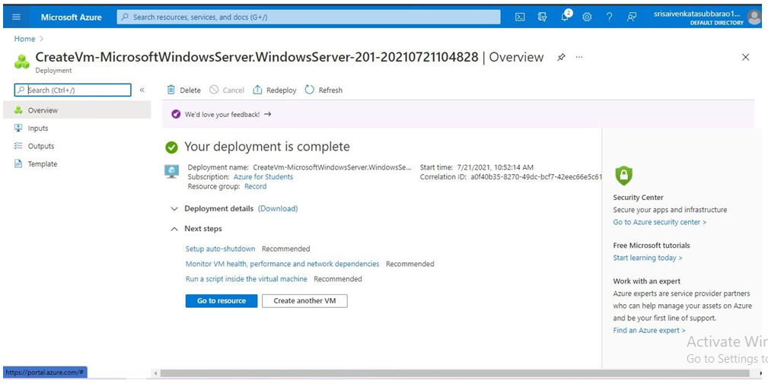

**EXP NO 15**

CREATE A SIMPLE WEB SITE USING ANY PUBLIC CLOUD SERVICE PROVIDER (AZURE/GCP/AWS) AND CHECK THE PUBLIC ACCESSIBILITY OF THE STORED FILE TO DEMONSTRATE STORAGE AS A SERVICE

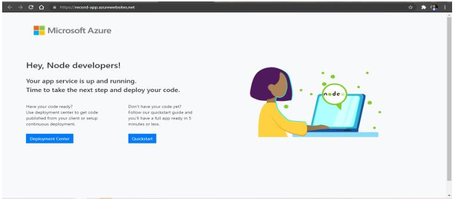

**EXP NO 17**

DEMONSTRATE INFRASTRUCTURE AS A SERVICE(IAAS) BY CREATING A VIRTUAL MACHINE USING A PUBLIC CLOUD SERVICE PROVIDER(AZURE/GCP/AWS) CONFIGURE WITH MINIMUM CPU, RAM AND STORAGE AND LAUNCH THE VM IMAGE.

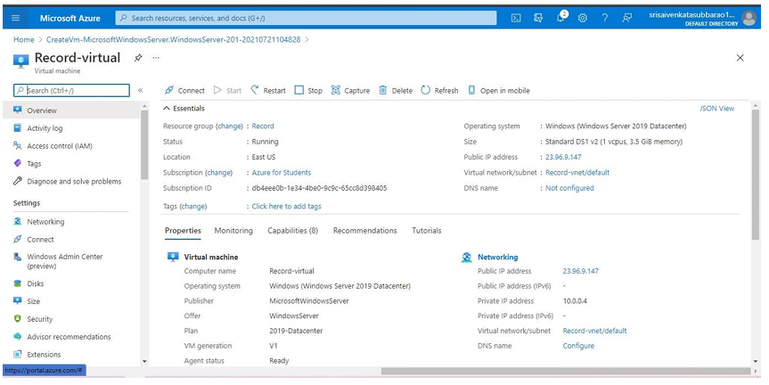

**EXP NO 19**

CREATE A STORAGE SERVICE USING ANY PUBLIC CLOUD SERVICE PROVIDER (AZURE/GCP/AWS) AND CHECK THE PUBLIC ACCESSIBILITY OF THE STORED FILE TO DEMONSTRATE STORAGE AS A SERVICE.

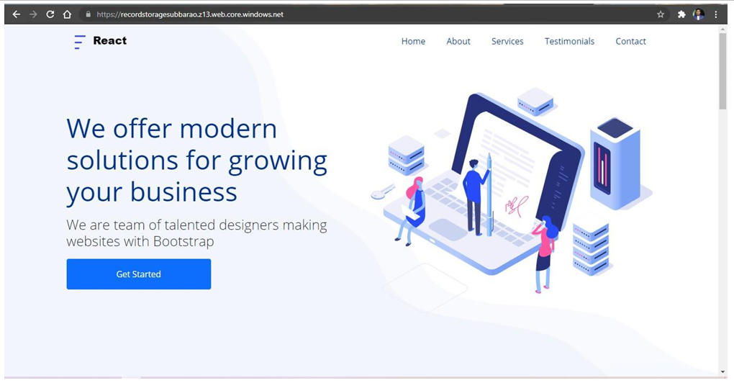

**EXP NO 20**

CREATE A SQL STORAGE SERVICE AND PERFORM A BASIC QUERY USING ANY PUBLIC CLOUD SERVICE PROVIDER (AZURE/GCP/AWS) TO DEMONSTRATE DATABASE AS A SERVICE (DAAS)

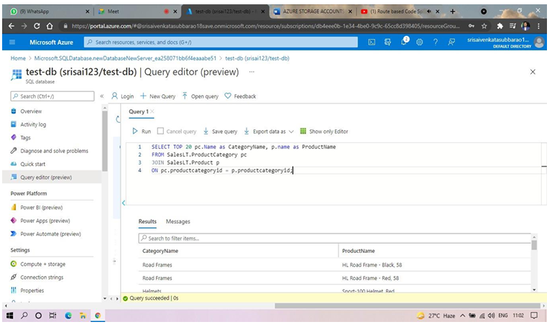

**EXP NO 22**

PERFORM THE BASIC CONFIGURATION SETUP FOR INSTALLING HADOOP 2.X LIKE CREATING THE HDUSER AND SSH LOCALHOST

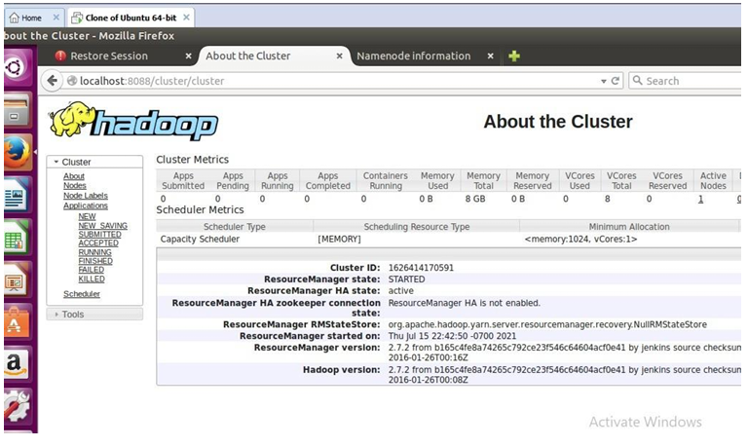

**EXP NO 23**

INSTALL HADOOP 2.X AND CONFIGURE THE NAME NODE AND DATA NODE.

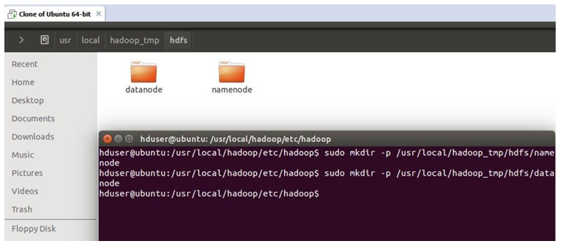

**EXP NO 24**

LAUNCH THE HADOOP 2.X AND PERFORM MAPREDUCE PROGRAM FOR A WORD COUNT PROBLEM

